Sound Signature Screens

Homepage

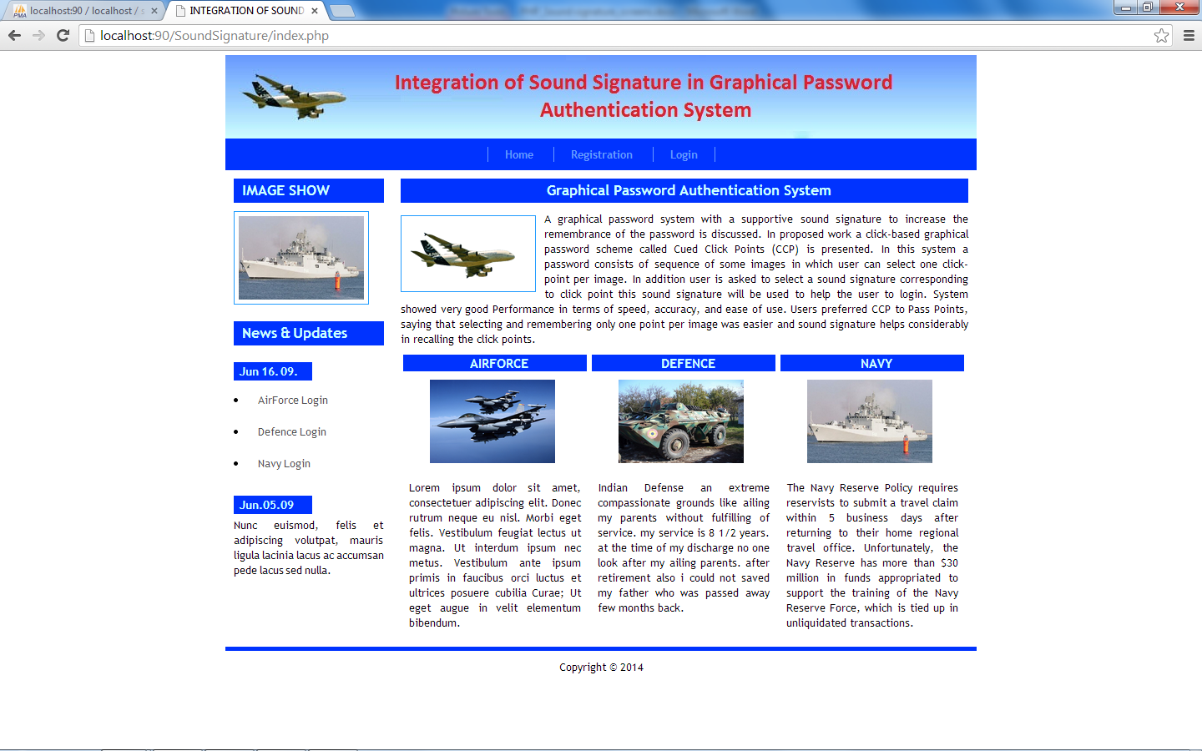

Airforce Registration

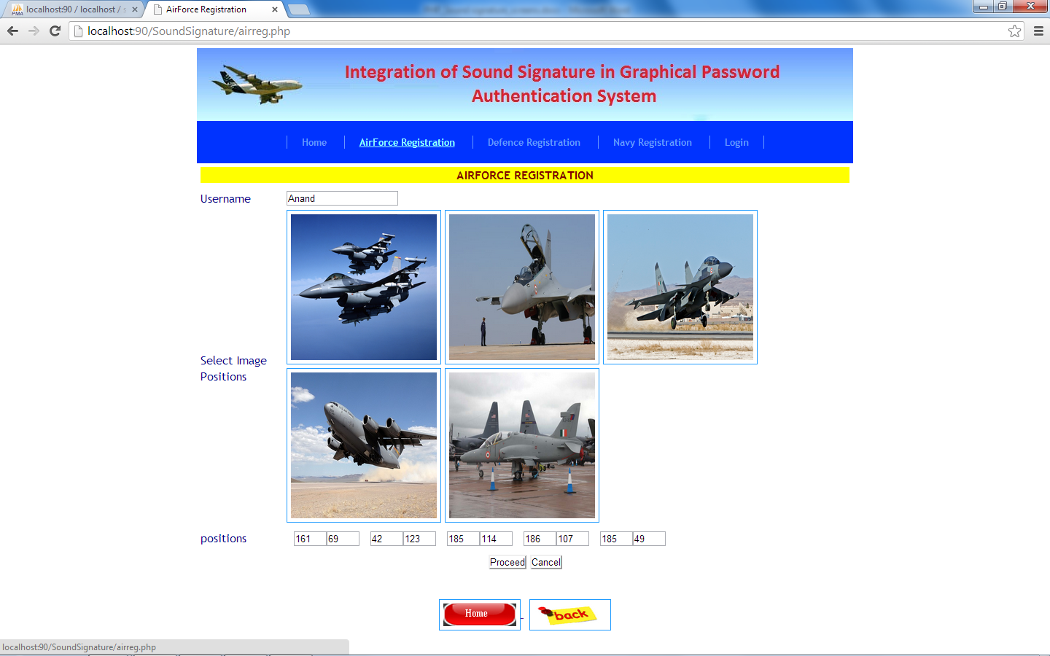

Contd

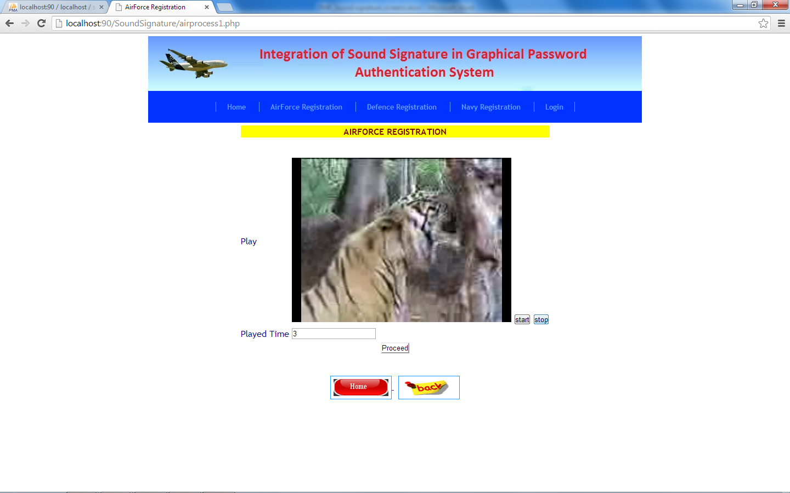

Contd

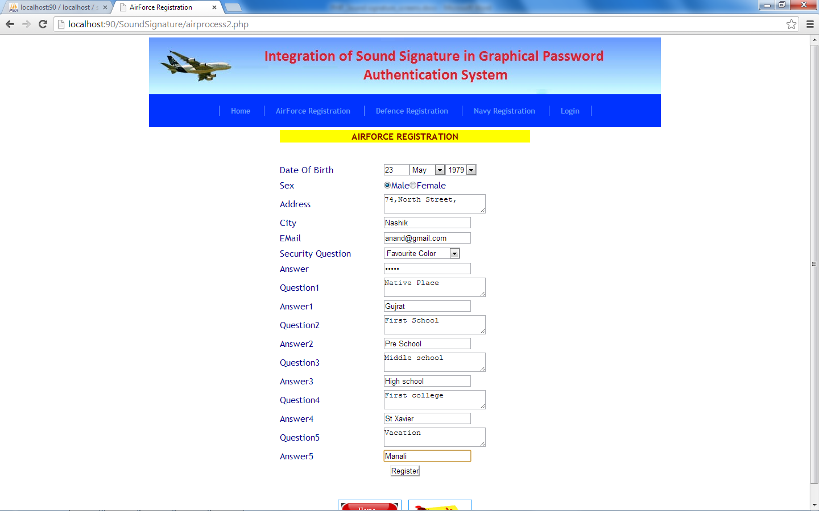

Defence Registration

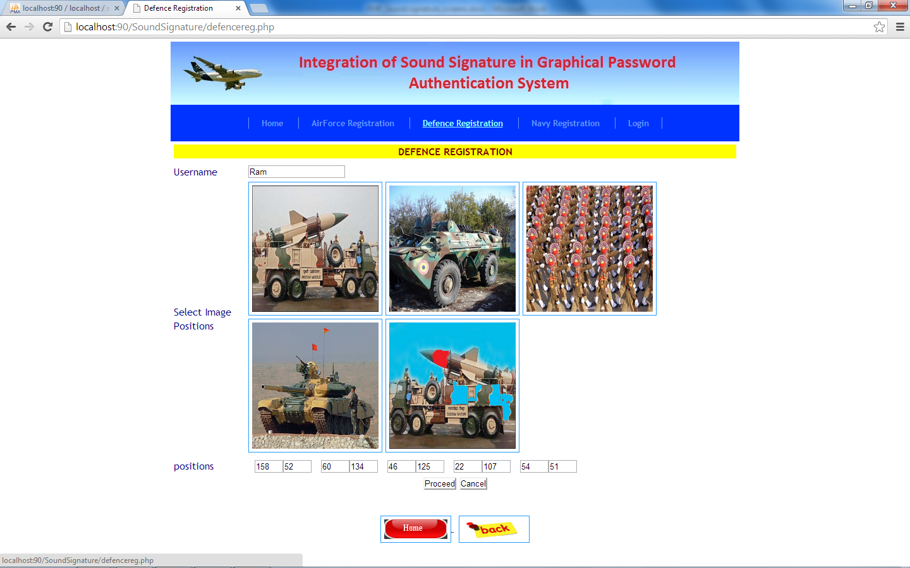

Contd

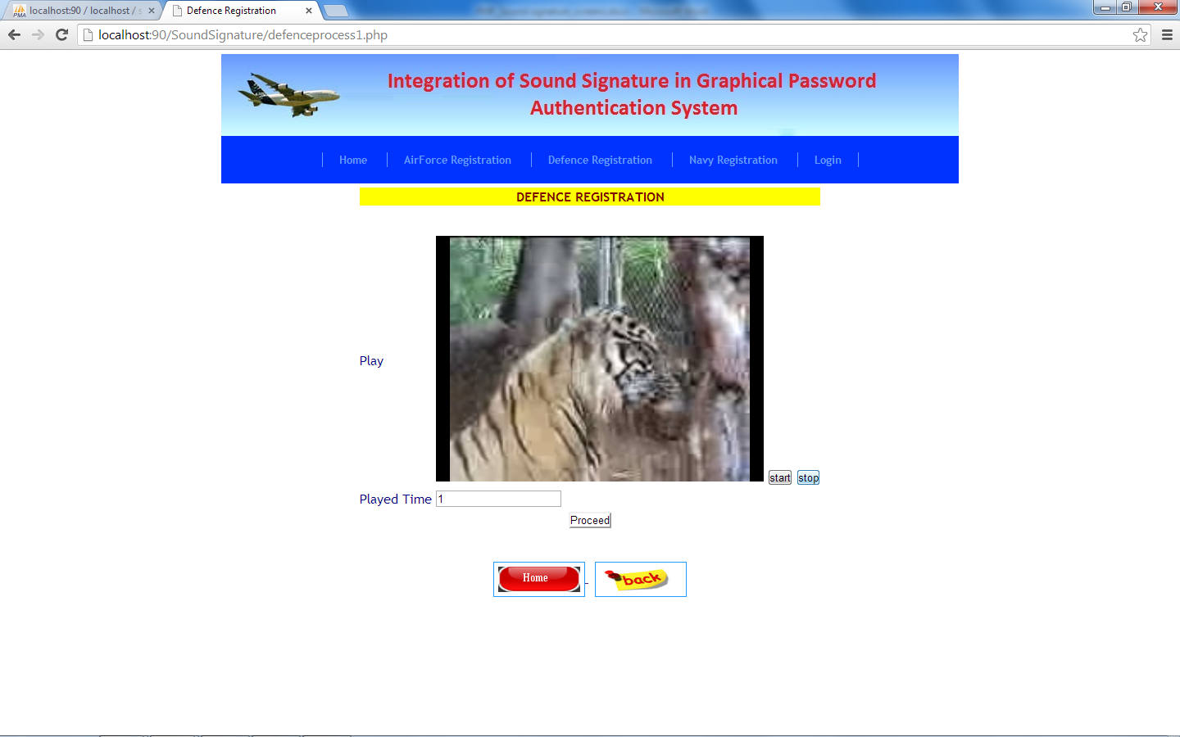

Contd

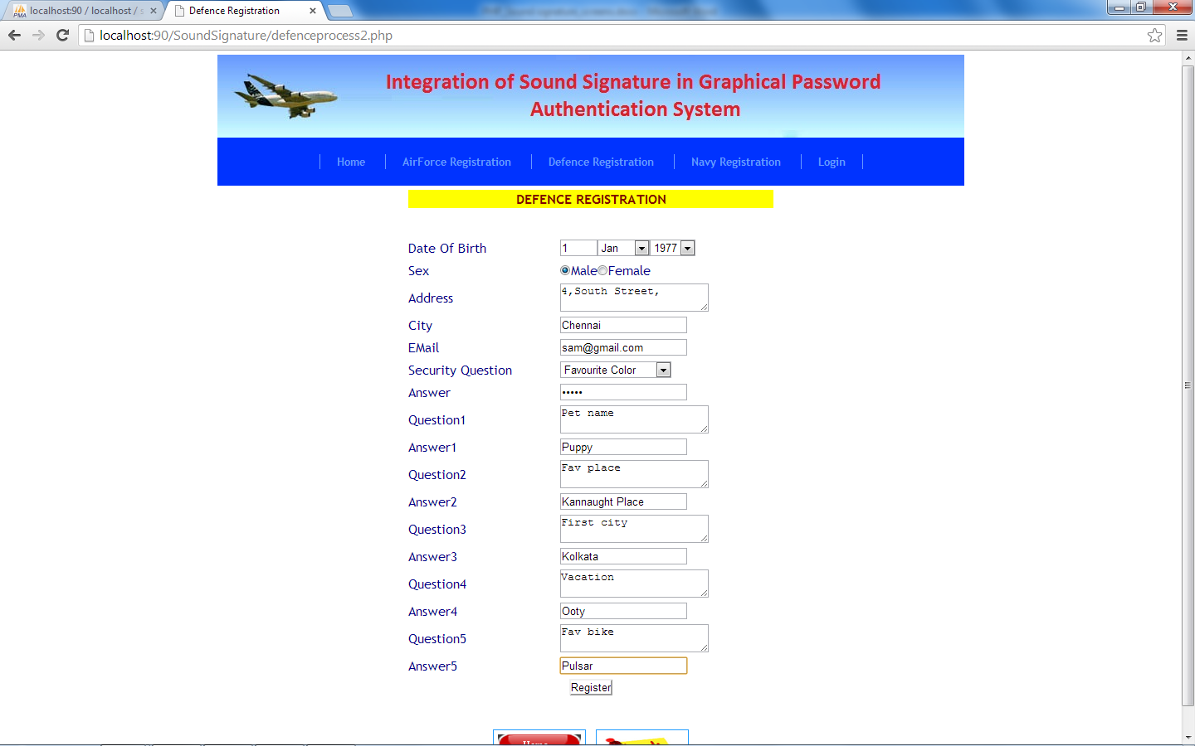

Navy Registration

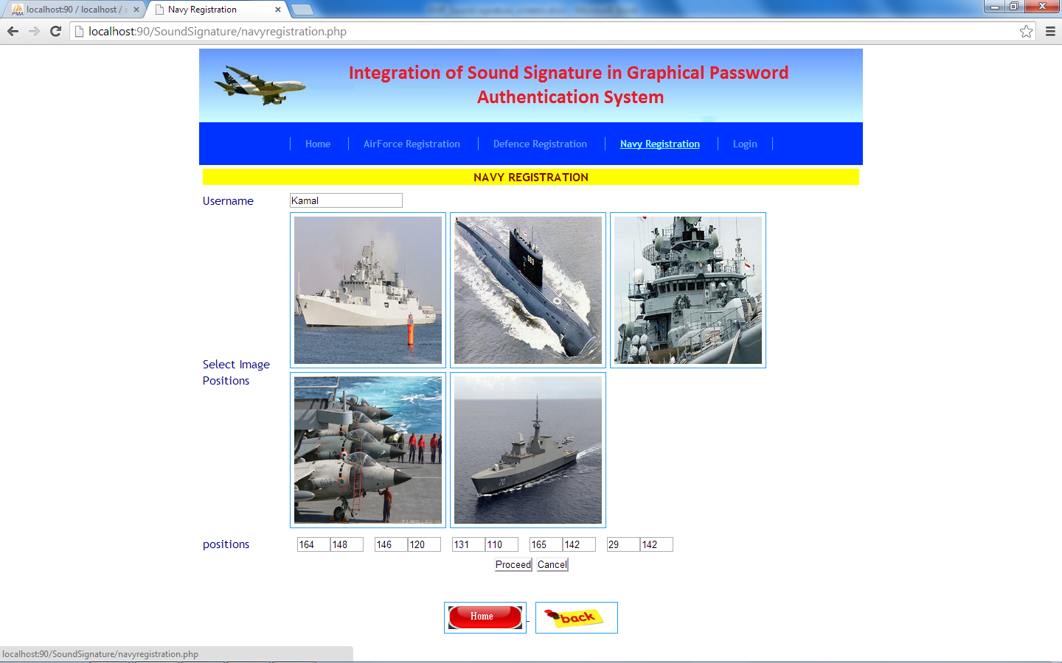

Contd

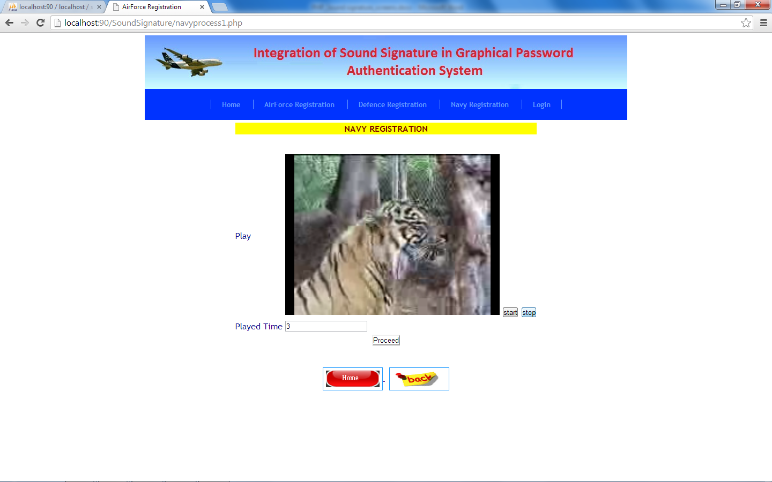

Contd

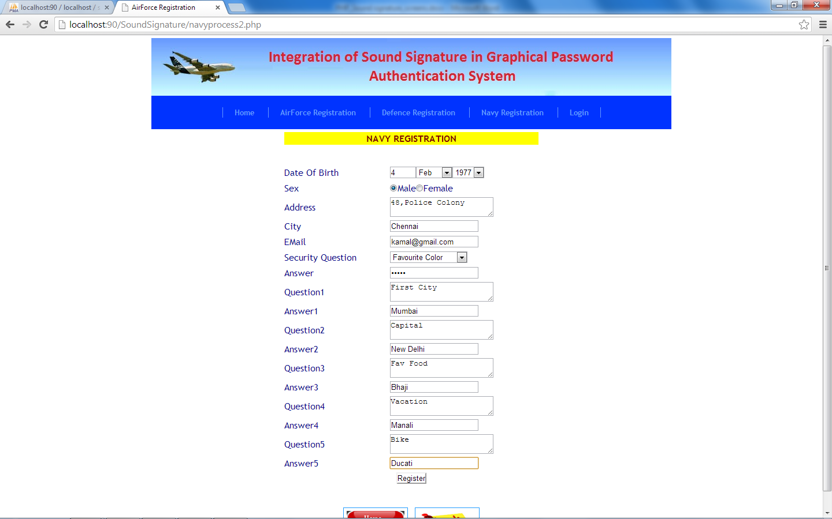

Confirmation

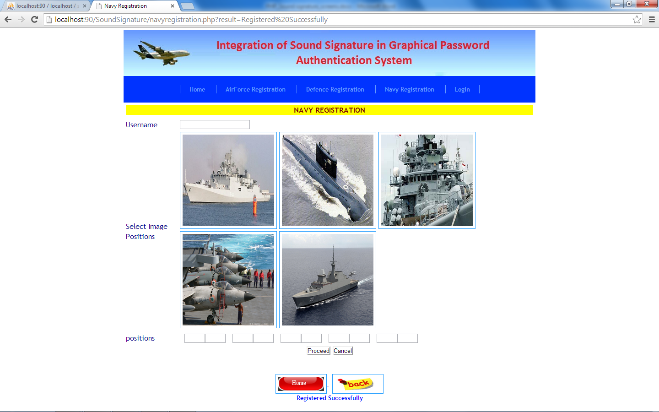

Login Page

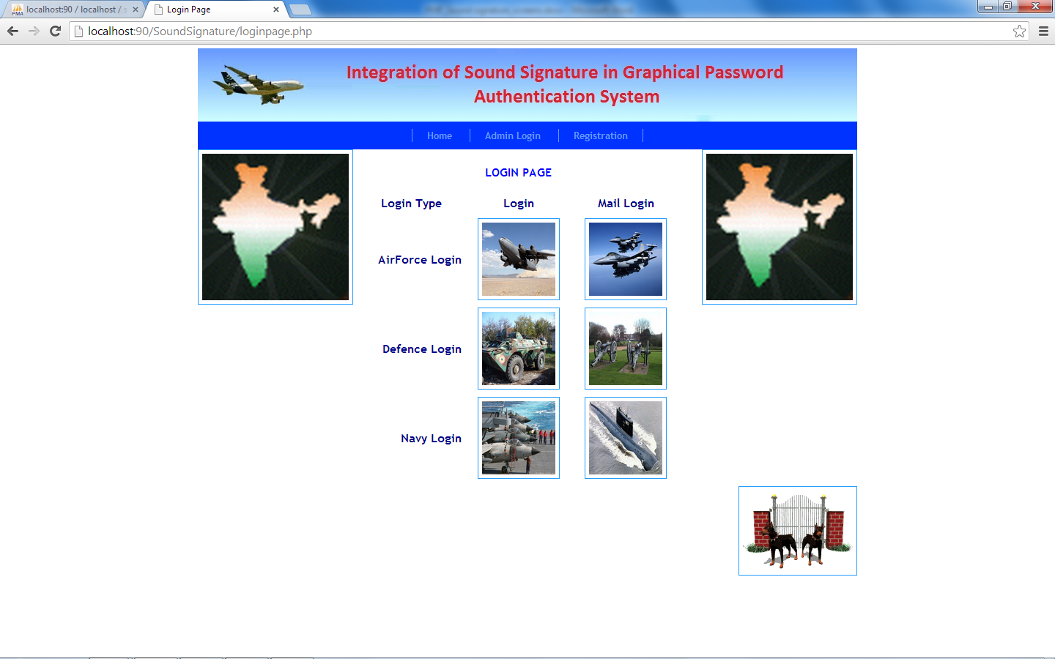

Airforce Login

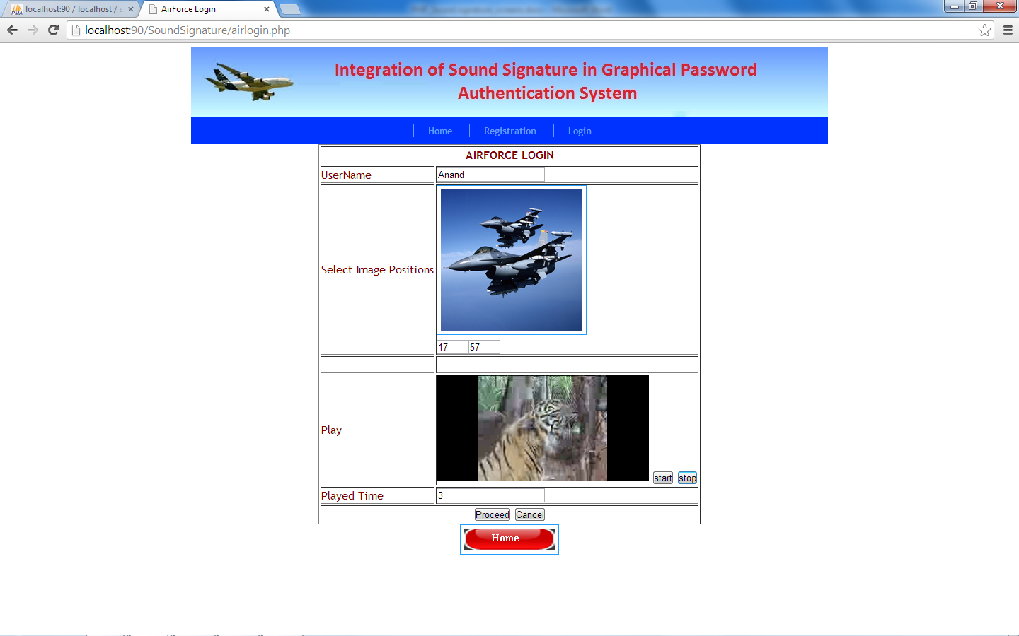

Contd

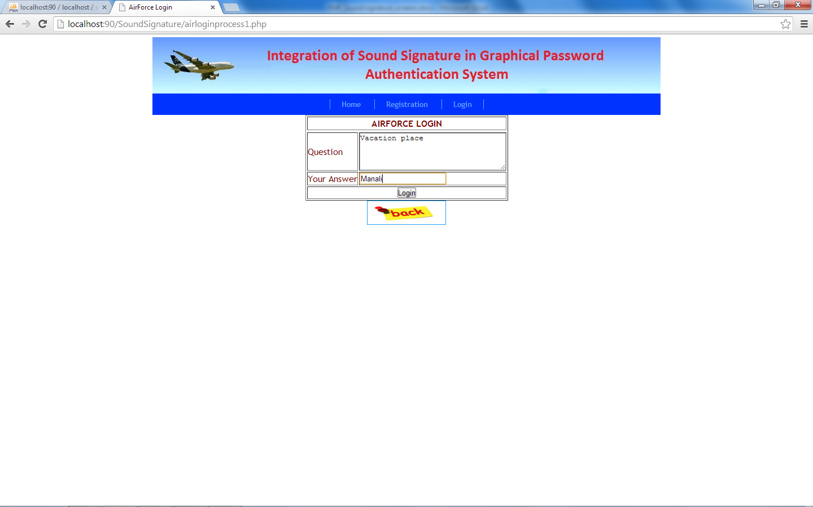

Airforce Home page

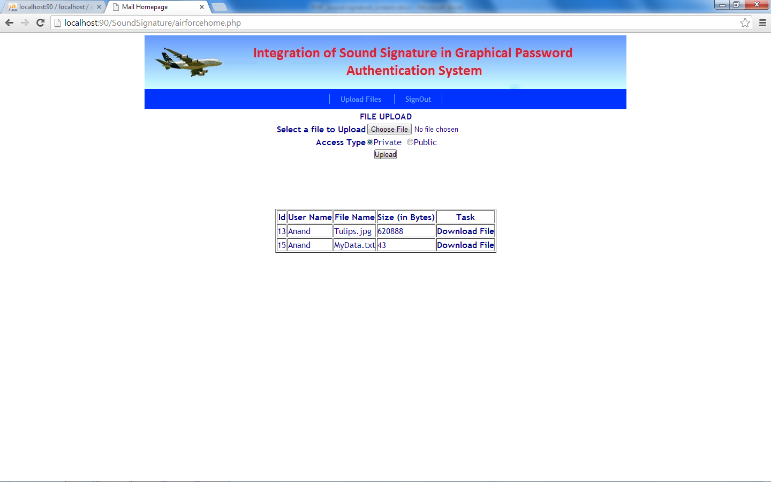

Upload Files

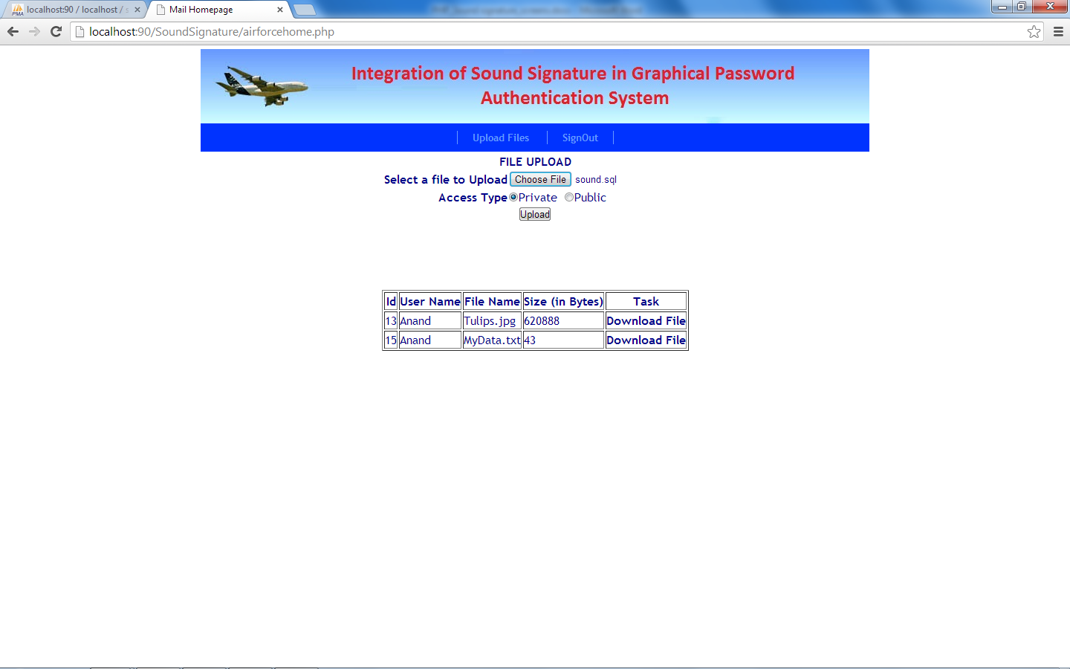

Download Files

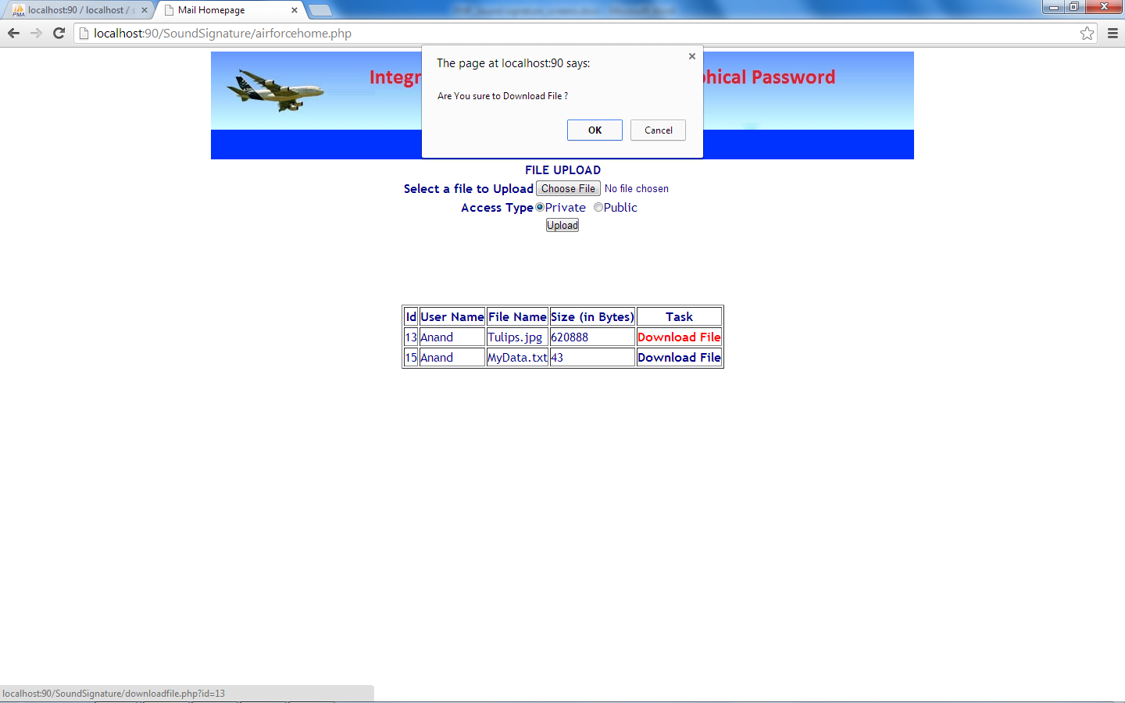

Mail Login

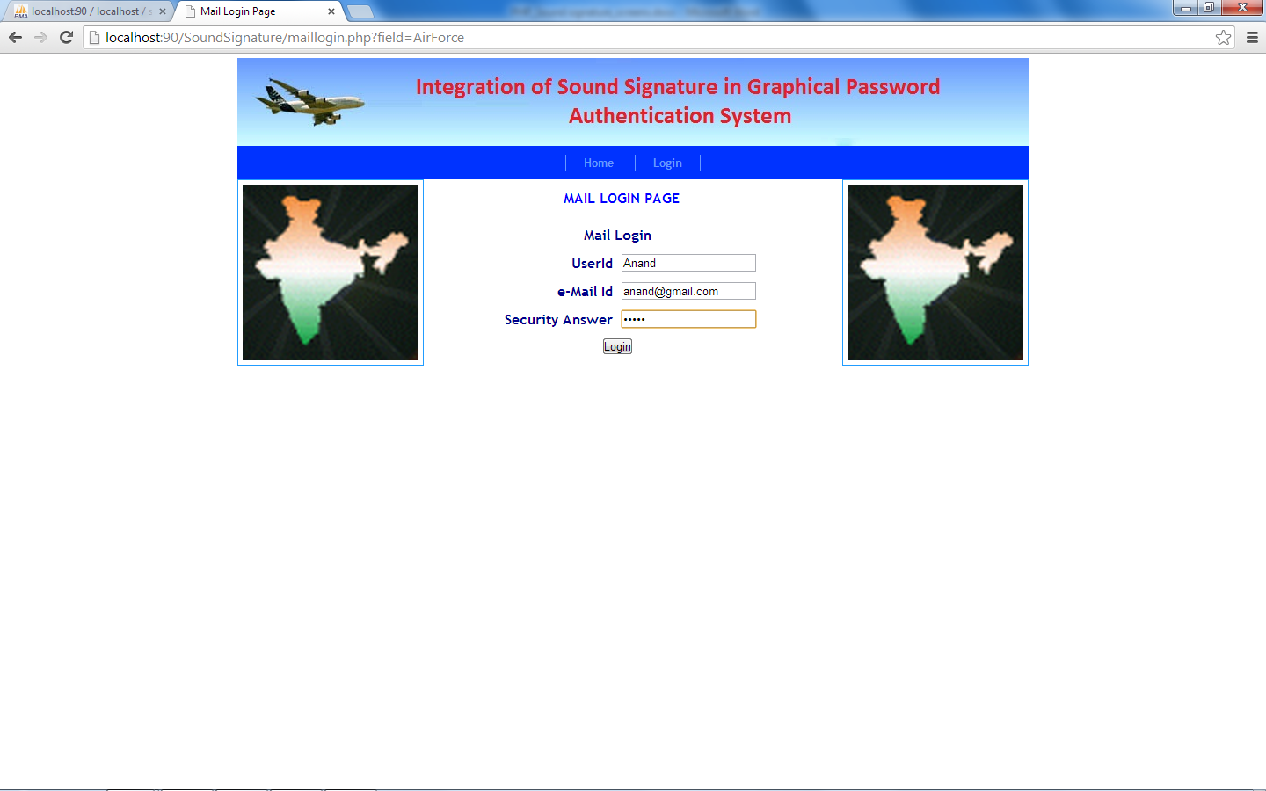

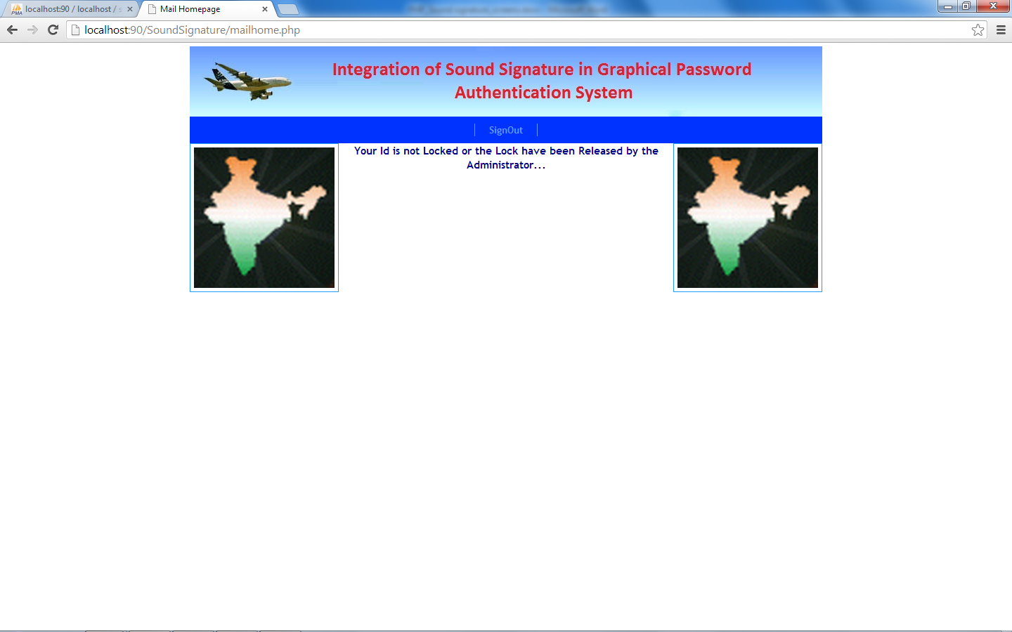

Admin Login

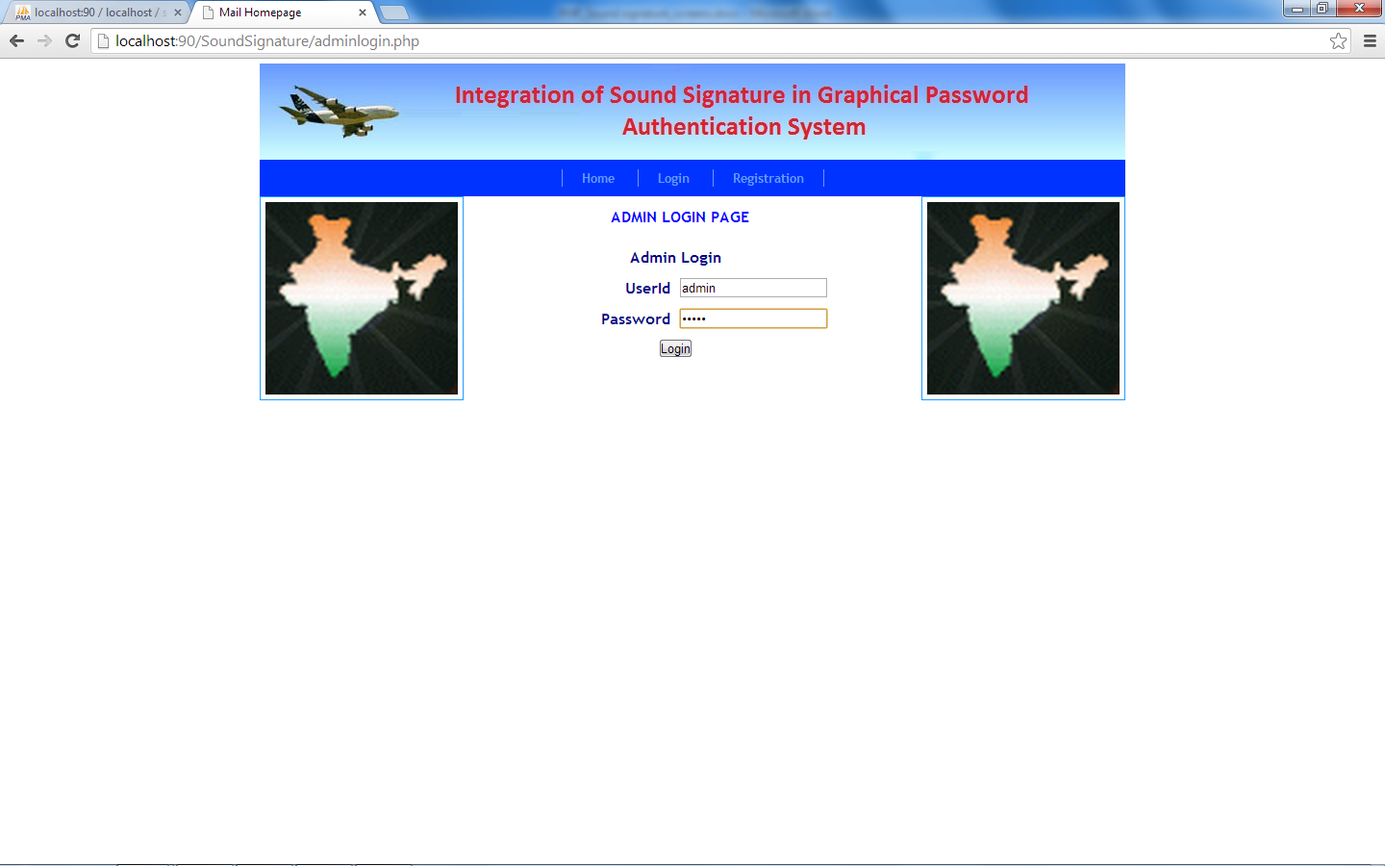

Releasing Lock

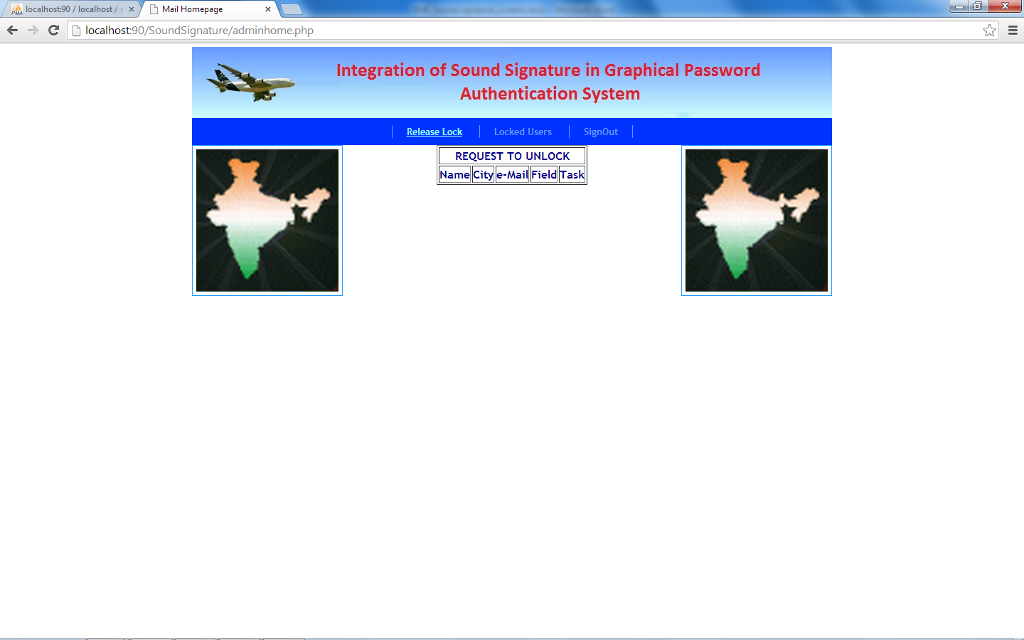

Locked Users

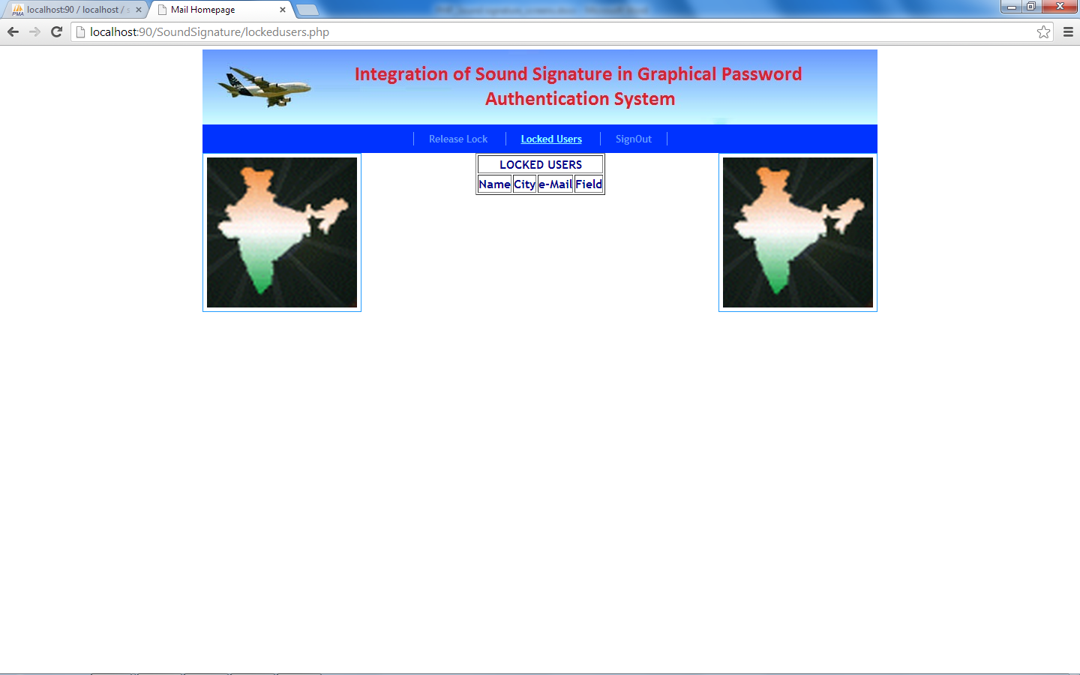

Soundreg

|  |  |  |
| --- | --- | --- |
| **Field Name** | **Datatype** | **Constraints** |
| sid | int(11) | Primary Key |
| name | varchar(100) | unique |
| x1 | int(11) |  |
| y1 | int(11) |  |
| x2 | int(11) |  |
| y2 | int(11) |  |
| x3 | int(11) |  |
| y3 | int(11) |  |
| x4 | int(11) |  |
| y4 | int(11) |  |
| x5 | int(11) |  |
| y5 | int(11) |  |
| dob | date |  |
| time | varchar(10) |  |
| sex | varchar(20) |  |
| address | varchar(100) |  |
| city | varchar(30) |  |
| email | varchar(100) | unique |
| field | varchar(20) |  |
| secqn | varchar(100) |  |

Uploads

|  |  |  |
| --- | --- | --- |
| **Field Name** | **Datatype** | **Constraints** |
| id | int(11) | Primary Key |
| name | varchar(100) |  |
| field | varchar(50) |  |
| fname | varchar(1000) |  |
| type | varchar(100) |  |
| size | varchar(50) |  |
| fpath | varchar(1000) |  |
| atype | varchar(50) |  |

userlock

|  |  |  |
| --- | --- | --- |
| **Field Name** | **Datatype** | **Constraints** |
| Name | Varchar(100) |  |
| Status | Varchar(20) |  |

DFD

User Login

Homepage

sounduser

Validate

uploads

Validate

userlock

Lock (Above 3 times)

Invalid

Valid

Valid

Invalid

Admin Login

Homepage

Validate

userlock

View Locked User

Invalid

Valid